

BBQRMS

BBQ RMS
You’re good at BBQ.
We’re good at the rest.

“This company shows a lot of spunk! They’ve got the BBQ industry nailed.”
Warron Buffet (Chairmen of the National Foundation of BBQ and BBQ Sauce, Austin, TX)
Testimonials
“The features in the BBQRMS help me make intelligent personnel changes. I can see my business grow and know when to hire more staff.”
(Ed Frank, Owner at Ed’s BBQ, Atlanta, GA)

“I used to lose sleep over spoiling inventory and fears about ordering too much or too little. Now with the BBQRMS at my side I can simply run a report to check my inventory and sleep well knowing my business is under control.”
(Dan Jacobsen Owner at Dan’s Pig and Cow Sundries, Memphis, TN)
CS3750
Group 4
https://code.google.com/p/cs3750g4/
http://groups.google.com/group/cs3750g4

code
site


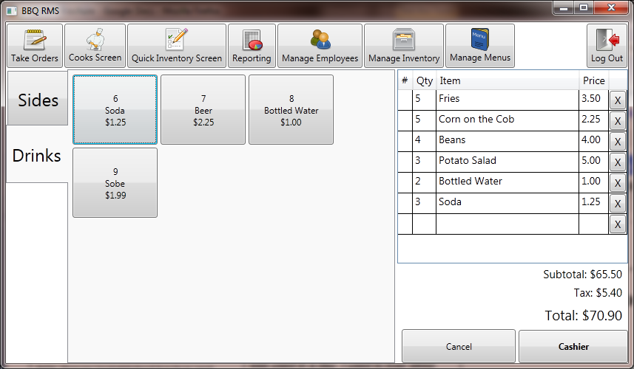
Order Entry Screen
Tracking orders has never been easier!

About BBQRMS
BBQRMS Project Team
Project Manager: Jerod T Hodgkin
Customer Liaison: Scott Leonard
Technical Lead: Mike Schenk
Senior Developer: Jessie Floyd

Technology Stack
- SQL Server (established backup and management tools, starting with the express edition.)
- Windows Communication Foundation (built into framework)
- Windows Presentation Foundation (built into framework)
- Microsoft Reporting supplied with Visual Studio
- Communication with web based virtual terminals for credit card processing

Features
- Inventory management
- Taking customer orders
- Integration with a 3rd party payment processing system
- Managing menus to support taking orders
- Integrating a flexible reporting package
- Creating an initial set of reports
- Employee schedule management

Future Features
- Menu management.
- Employee management with security roles.
- Time clock functionality.
- Credit card processor integration.
- Ability to print receipts, reports and other things.
- Manager Dashboard

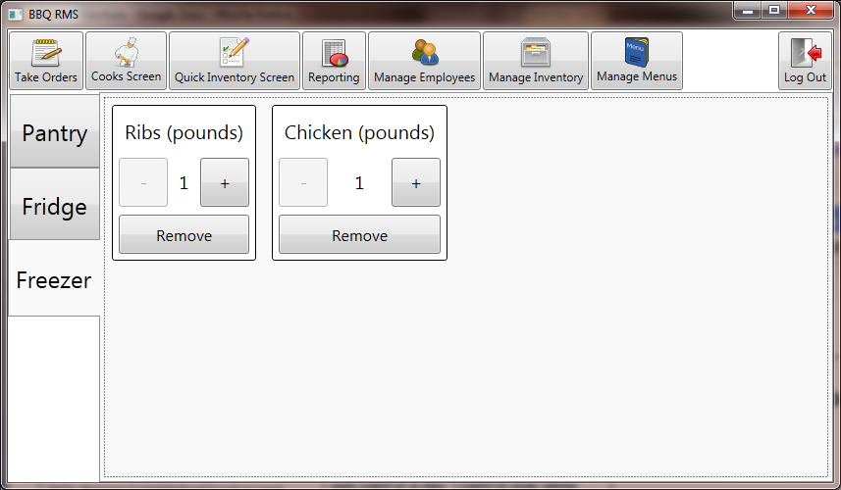
Quick Inventory Screen
tracks all of the inventory on the fly!

“The sauce is so good I brush my teeth with it. Oh, yeah, the RMS is pretty good too.” (Pete Toole BBQ Connoisseur, St. Louise, MI)
Software Requirements
- Windows XP SP3 and above
- SQLServer 2005 and above
- .Net 4.0

Supported Hardware
- Card reader
- Receipt printer
- Cash drawer
- Possibly bump-bar
- Touchscreen
- Keyboard/mouse

Technical Specification
2010 CS3750 Group 4
BBQRMS
Weber State University

